01st March 2019

**YOKOHAMA to Exhibit at 2019 Geneva Motor Show**

YOKOHAMA announced today that it will participate in the 2019 Geneva International Motor Show. The 89th edition of the show will be held during 7th – 17th March, with press days on 5th – 6th March. As in 2018, the YOKOHAMA booth will include presentations related to the Company’s consumer tyre strategy in its current three-year medium-term plan, “Grand Design 2020 (GD2020)”, which was implemented from 2018. Many new tyre products will be on display, and a press conference introducing the new products is scheduled to be held at the YOKOHAMA booth (Hall 4, Booth No. 4231) on 5th March from 3:45 p.m.  
  
To further promote the awareness of YOKOHAMA’s presence in the premium tyre market, a key theme of GD2020’s consumer tyre strategy, this year’s booth at Geneva will feature exhibits highlighting the plan’s strategies for premium car tyres, winter tyres, and hobby tyres.   
  
The premium-car strategy exhibit will introduce YOKOHAMA’s track record as a supplier of original equipment (OE) tyres for many of the world’s premium car models. The display will include the “ADVAN Sport V105”, YOKOHAMA's flagship tyre for high-power premium cars.   
  
The winter-tyre strategy exhibit will display several tyres from YOKOHAMA’s diverse winter-tyre line-up, including the “BluEarth-4S AW21”, an all-season tyre for the European passenger car market; “iceGUARD iG60”, a passenger-car studless tyre that achieves the highest performance levels of any studless ever produced by YOKOHAMA; and the “BluEarth＊WINTER V905”, a highly fuel-efficient winter tyre for passenger car and SUVs.   
  
The hobby tyre strategy exhibit will include new street sports tyres that will be sold only in Europe. The hobby tyre area also will feature a mud-terrain tyre for SUVs and pickup trucks making its debut on the European scene, and other products that enhance a vehicle’s image as a hobby car, including some new products targeted at historic car owners. In addition, visitors to the exhibit will be able to see a NISSAN GT-R outfitted with “ADVAN A052” street sport tyres, one of the core tyres in the Company’s hobby tyre strategy.   
  
This year’s YOKOHAMA booth at Geneva will also feature special corners that introduce visitors to YOKOHAMA’s involvement in the FIA World Touring Car Cup (WTCR) as supplier of control tyres for the races and the Company’s partnership with English Premier League team, Chelsea FC. An additional highlight of YOKOHAMA’s participation at the Geneva Motor Show will be the attendance of Chelsea Legend Didier Drogba. Drogba will take part in a fan Q&A at the Yokohama booth on Friday 8th March, discussing his time at Chelsea and role as a YOKOHAMA ambassador.

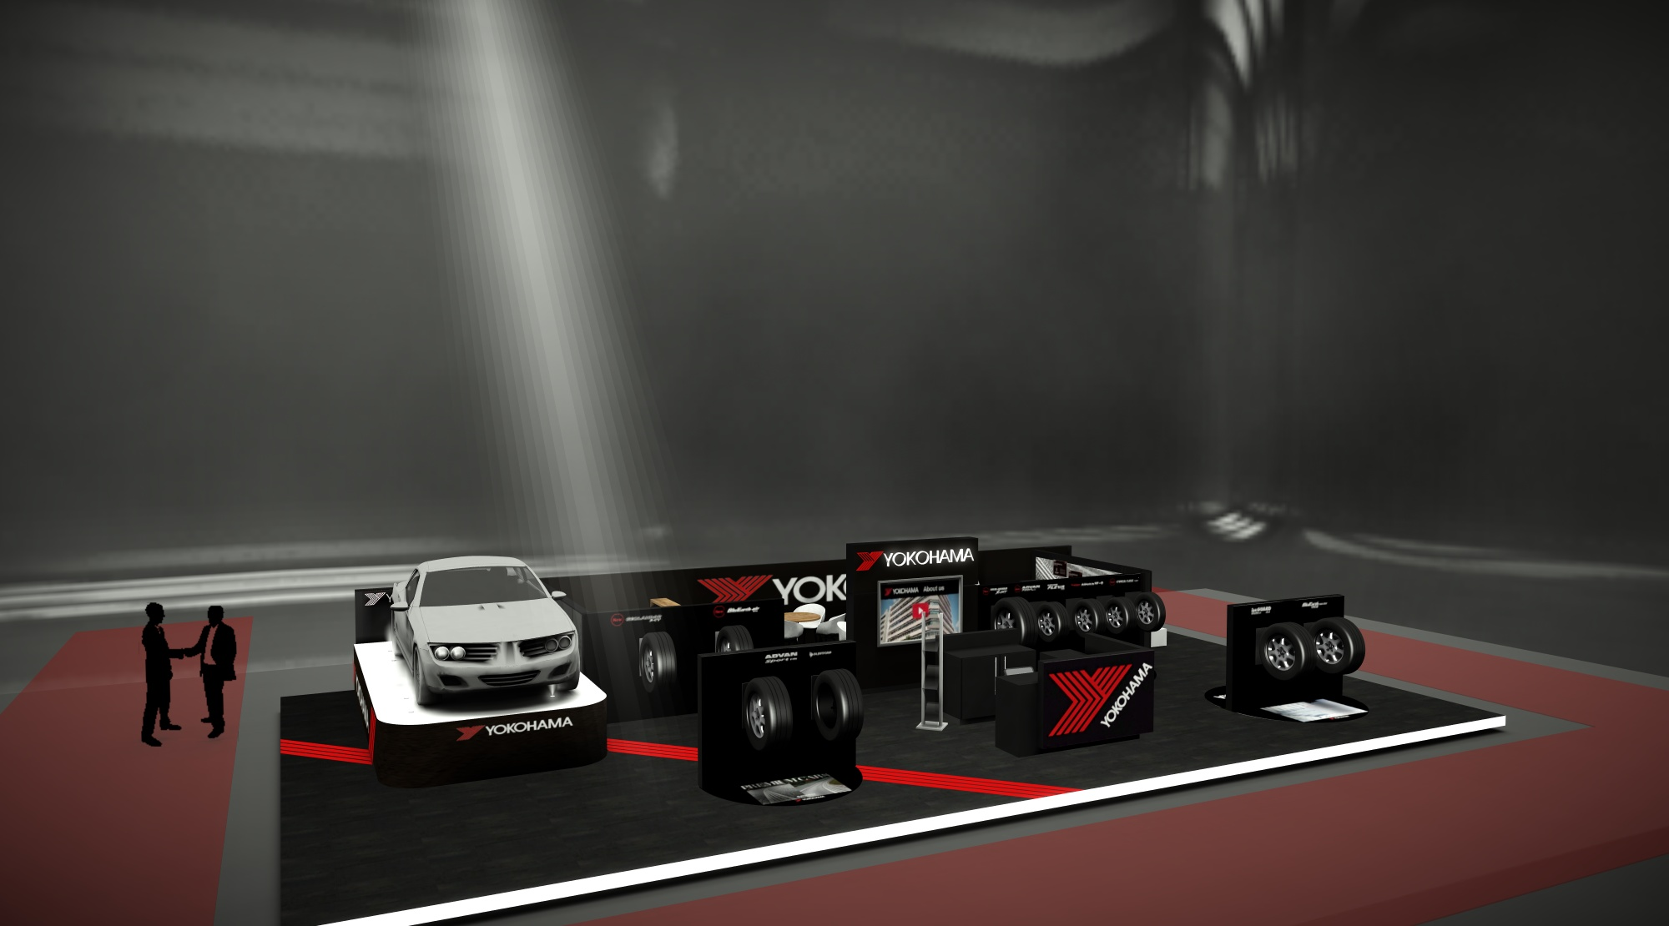

*Artistic impression of the YOKOHAMA Booth*